Develop A Web Application Using Node-RED Service

|  |  |
| --- | --- |
| Team ID | PNT2022TMID46761 |
| Project Name | Real-time river water quality monitoring and control system |

# Create An HTTP Requests To Communicate With Mobile App

## Creating the HTTP request in Node-RED

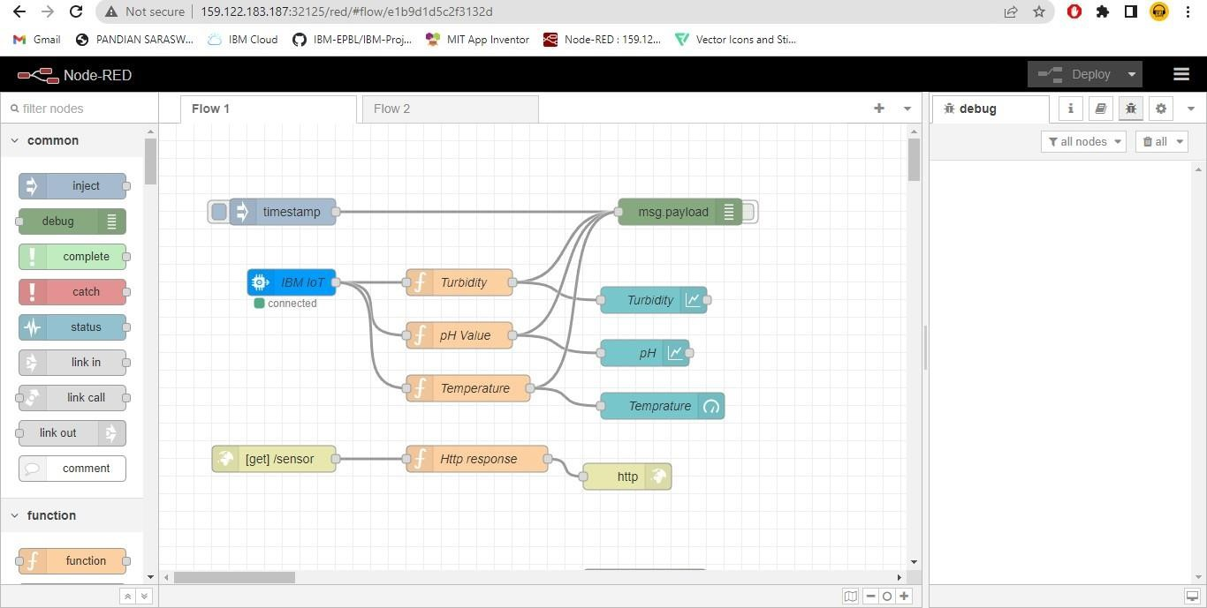

**OUTPUT**

## Image 1

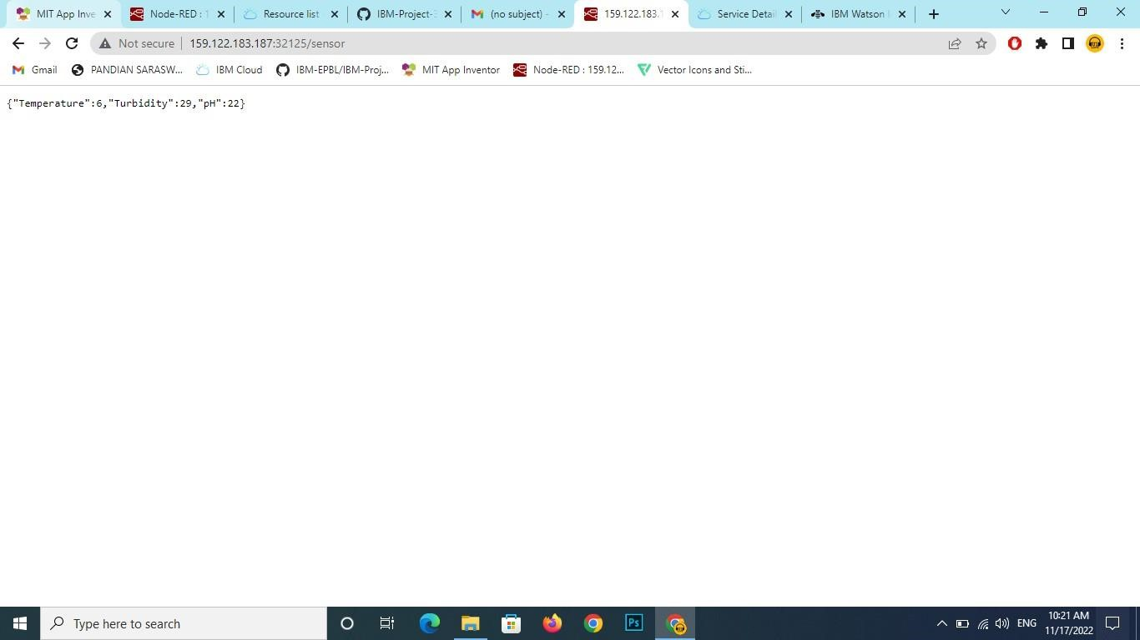

Image 2

